KPI Metrics

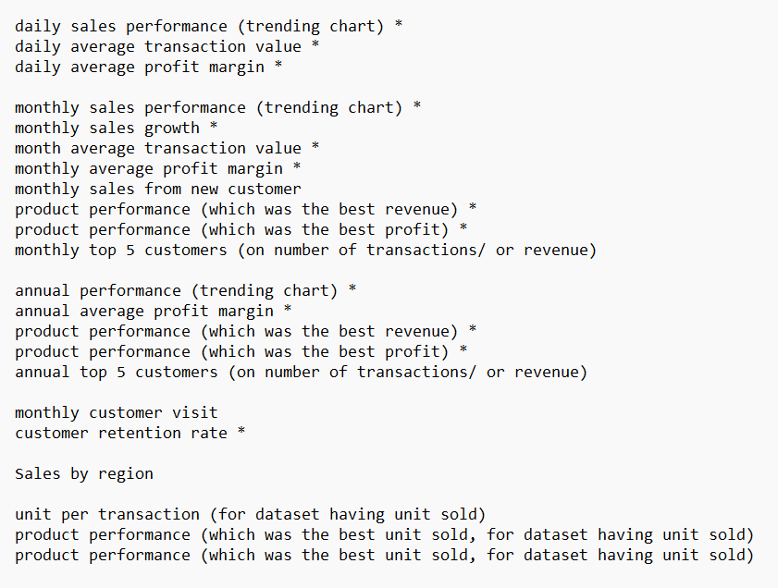
Average Transaction Value (ATV)
The Average Transaction Value is essential for assessing the financial performance of a retail store. It’s calculated by dividing total sales revenue by the number of transactions.
This KPI can highlight issues with your product mix, pricing strategy, or customer traffic.
To increase your ATV, consider strategies such as:
- Upselling, encouraging customers to choose higher-end products
- Cross-selling, suggesting complementary products
- Promoting add-on purchases at checkout
Daily ATV = total sales revenue/the number of transactions.
Monthly ATV = total sales revenue/the number of transactions.

Sales Growth
A business can survive for only so long without growing its sales. By tracking this metric in your monthly sales dashboard, leaders can quickly spot problems and act on trends. Establishing realistic monthly sales growth targets can motivate a sales team and ensure consistent alignment of their efforts with an organization’s expectations. The formula for monthly sales growth is:
Monthly sales growth =
((Sales for the current month - sales for the prior month) / sales for the prior month) x 100
Annual sales growth =
((Sales for the current year - sales for the prior year) / sales for the prior year) x 100

Average Profit Margin
Average profit margin is how much of overall sales revenue results in profits and is an important financial KPI. It’s calculated by subtracting the costs associated with producing the company’s goods and services from sales revenue. Companies can also analyze profit margins generated by specific products, sales territories and salespeople. Businesses with a wide range of products or services should monitor profit margins closely, as should companies that allow their sales reps flexibility in setting prices. This can be monitored for overall average profit margin or for specific areas. The formula for average profit margin is:
Daily/Monthly/Annual Average profit margin = (Net income / net sales ) X 100

Product Performance
Which products are top-selling, and which are behind the pack? This product performance and inventory KPI answers these questions by ranking products based on sales.
Product sales volume doesn’t always directly correlate to revenue performance. Low-price but high-volume products may account for a significant portion of total sales but may not rank in the top 10 revenue-generating products. As with most metrics, it’s important to consider other factors surrounding the product. For example, is a product experiencing a boost due to a concentrated marketing campaign? Or did a product slip because the competition rolled out an updated version at a lower price? Sales leaders can use the rankings to evaluate product market trends, while sales managers can use product performance to adjust their sales plans based on these trends
- Monthly product performance (which was the best revenue) *
- Monthly product performance (which was the best profit) *
- Annual product performance (which was the best revenue) *
- Annual product performance (which was the best profit) *

Customer retention rate
Retention rate measures the proportion of existing customers who continue purchasing from you over time:
[(Customers at end of period – New customers) ÷ Customers at start of period] × 100
It’s a reliable indicator of loyalty and long-term engagement.

Monthly Customer Visit

FOR DATASET HAVING UNIT SOLD
- unit per transaction (for dataset having unit sold)
- product performance (which was the best unit sold, for dataset having unit sold)
- product performance (which was the best unit sold, for dataset having unit sold)

